**Drawing Trapezium**

You are given a Trapezium ABCD,

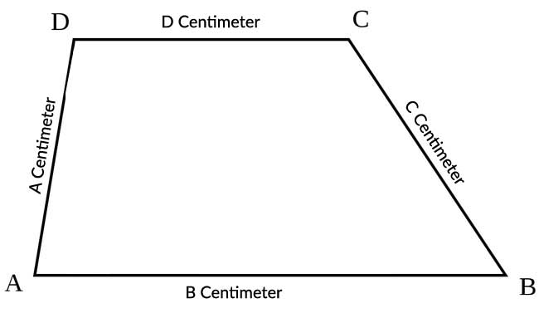

A : x1, y1

B : x2, y2

C : x3, y3

D : x4, y4

Also Given the length of Sides

AB : a cm

BC : b cm

CD : c cm

DA : d cm

You have to Draw this trapezium.

1. Show vertices as shown in figure
2. Show labels on side as shown in Figure